Write a program to configure JSP with Eclipse and Creating a Simple JSP Page.

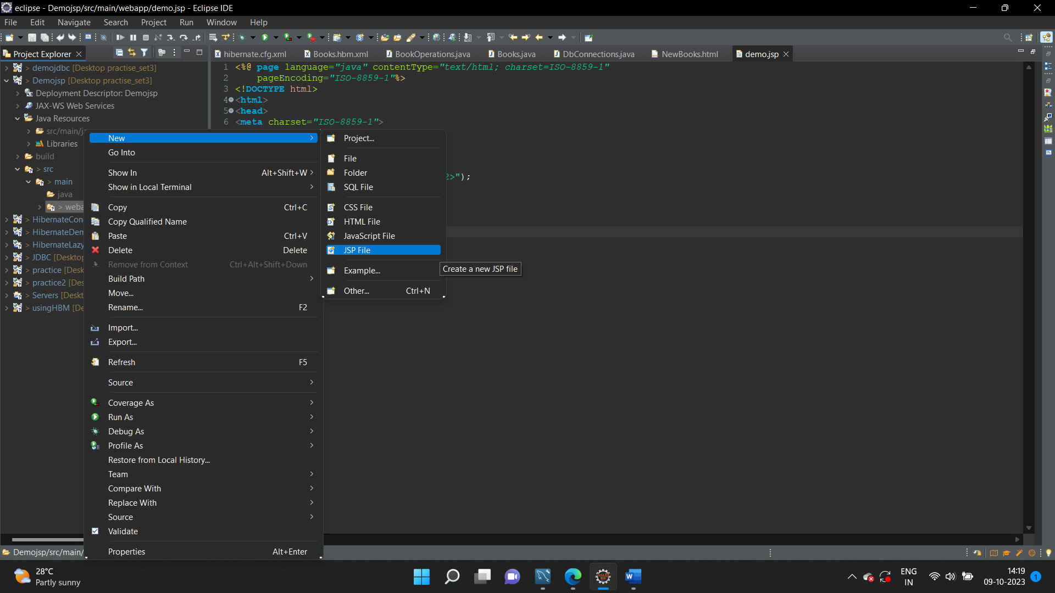

Creating jsp Page

<%@ **page** language=*"java"* contentType=*"text/html; charset=ISO-8859-1"*

pageEncoding=*"ISO-8859-1"*%>

<!**DOCTYPE** html>

<**html**>

<**head**>

<**meta** charset=*"ISO-8859-1"*>

<**title**>Insert title here</**title**>

</**head**>

<**body**>

<%

out.println("<h2>My first JSP page.</h2>");

%>

</**body**>

</**html**>